# **2023 Aviation Art Contest Rules**

# 

| Your Checklist |
| --- |
| [__] Read Directions Here and watch direction video on Mrs. Dykes’s homepage using the QR Code to the right  [__] Use provided 11 ¾ x 16 ½ sized paper  [__] Return artwork with the form on the last page “North Carolina Art Contest Certificate of Authenticity” on or before January 13th to be mailed with the rest |

# The annual North Carolina Aviation Art Contest offers all children ages 6-17 who live or attend school in North Carolina the chance to explore different aspects of aviation.

**Now accepting entries through Jan. 13, 2023**

​**Theme: “Air Sports & The Environment.”**

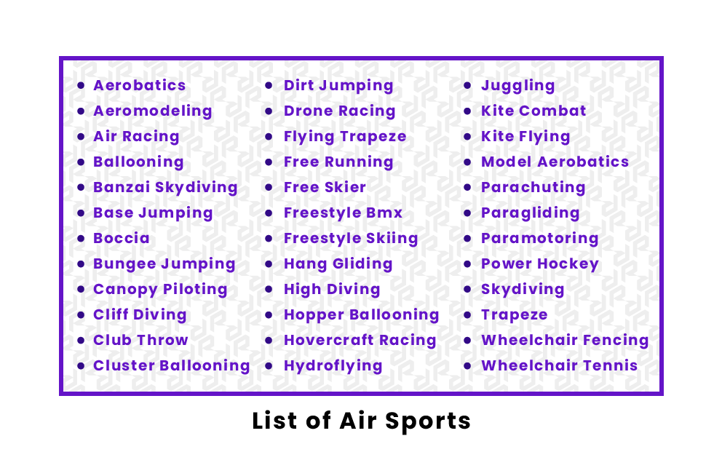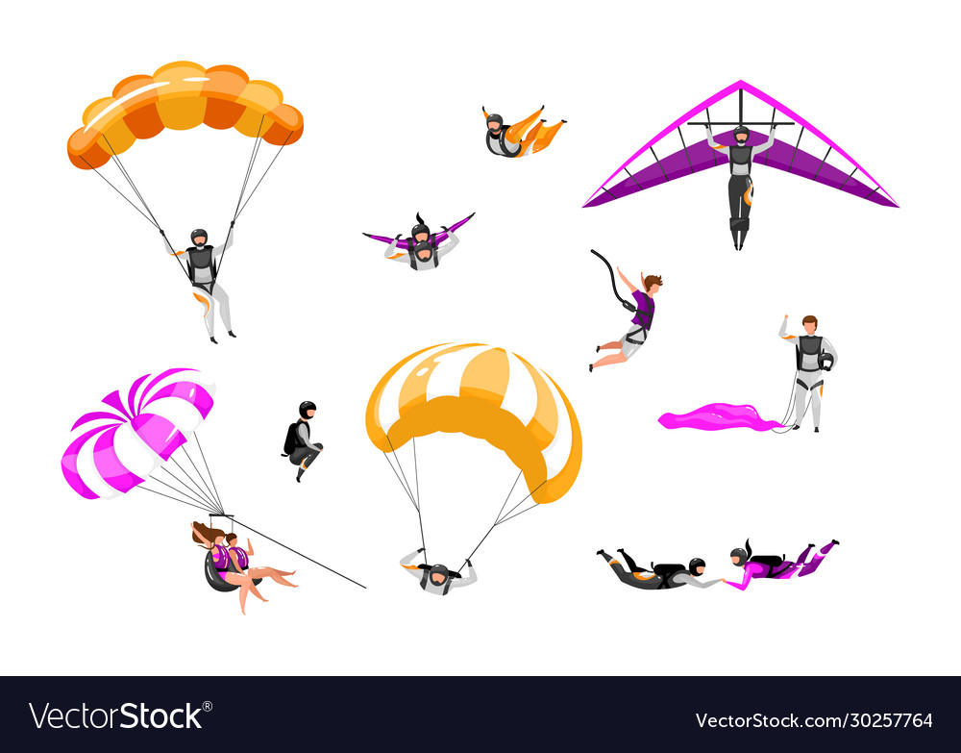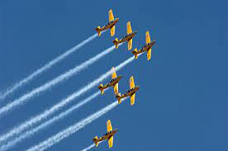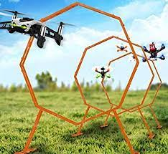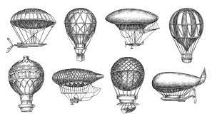 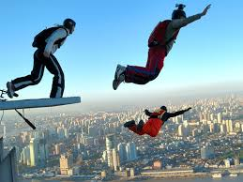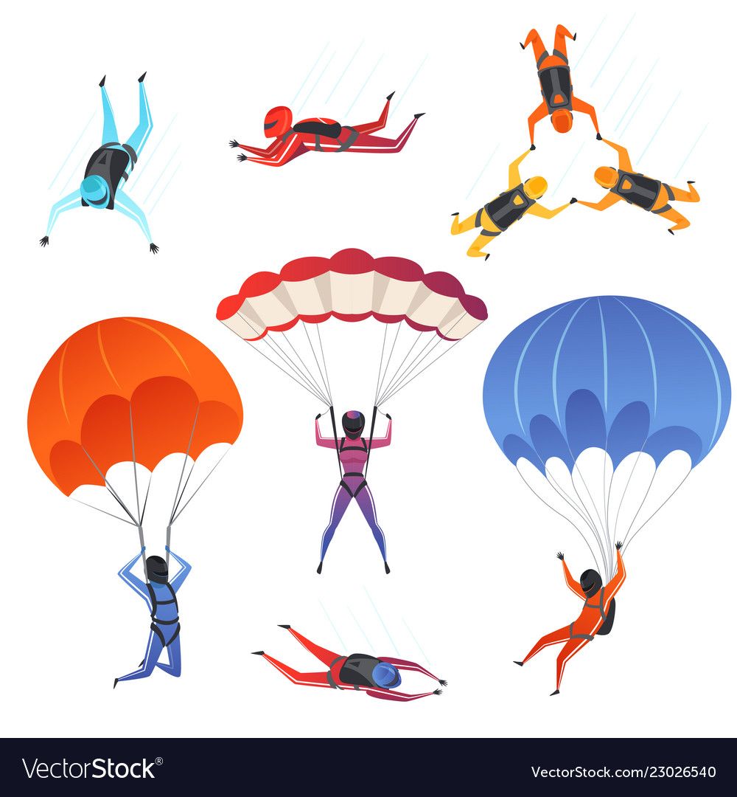

| **School Based Contest Information** |
| --- |
| -All entries will go to both school and state  -For our school contest there will be 6 winners in the following categories who will receive prizes:   | 1st Place K-2 | 1st Place 3-5 | | --- | --- | | 2nd Place K-2 | 2nd Place 3-5 | | 3rd Place K-2 | 3rd Place 3-5 | |

## 

| **​State Contest Requirements Information** |
| --- |

### Eligibility

All children who live in and/or attend school in North Carolina and are in the age groups below are encouraged to participate. Children who are related to officials and employees of the N.C. Department of Transportation are eligible to participate.

### Age Groups

| Category | Age Range |
| --- | --- |
| Junior | Date of birth between Jan. 1, 2013, and Dec. 31, 2016 |
| Intermediate | Date of birth between Jan. 1, 2009, and Dec. 31, 2012 |
| Senior | Date of birth between Jan. 1, 2005, and Dec. 31, 2008 |

Additional information is available on the [website of the National Association of State Aviation Officials.](http://www.nasao.org/education/nasao-center-for-aviation-research-and-education/international-aviation-art-contest/) https://nasao.org/page/education

### Format

The required format is 11¾ x 16½ inches (paper size A3) or, if this is unobtainable, the nearest possible equivalent. Artwork must NOT be framed or outlined with borders.

### Medium

All artwork must be by hand (or, in the case of children with physical challenges, by foot or mouth).

**Permitted Media/ Materials**

Watercolor

Acrylic

Oil paint

Indelible marker pens (non-erasable)

Felt-tip pens

Soft ballpoint pens

Indelible ink (non-erasable)

Crayon

Other similar indelible medium (non-erasable)

**Prohibited Media / Materials**

Pencil

Colored pencil

Charcoal or other non-permanent medium

Computer-generated artwork

Collage work involving the use of photocopies

### Title

A title on the artwork is not required, and entrants can decide for themselves whether to include one. However, there should be a clearly recognizable link to the theme of the content.

### Markings

The artist's name should not appear on the front of the artwork. **The following information should be clearly shown on the back of the artwork:**

Family name, given name

Address

Date of birth

Country of residence

Name and address of school

Title of the artwork (if desired)

### Certification

A parent, guardian or art teacher must certify the authenticity of the artwork and the age of each artist. The [Certificate of Authenticity​](https://www.ncdot.gov/initiatives-policies/students-youth/aviation-art-contest/Documents/certificate-authenticity.pdf) must be completed and mailed with the artwork.

### Reproduction Rights

Once received, all entries will become and remain the properties of the N.C. Department of Transportation Division of Aviation and may be used for a variety of purposes.

Artwork that does not place at the national level may be returned if the student or school provides the adequate return postage and package. Artwork forwarded for international judging becomes the property of the Fédération Aéronautique Internationale; however, FAI will try to return the original artwork.

## Awards

### State Awards

Entries in each age group will be judged, and state winners and runners-up will be selected. The top three entries in each age group will be forwarded to Washington, D.C.,​ to be judged in the national competition.

The [North Carolina Airports Association](http://ncairports.org/) will present the following awards to state winners:

| Age Group | First Place | Second Place | Third Place |
| --- | --- | --- | --- |
| Junior | $75 | $50 | $25 |
| Intermediate | $100 | $75 | $50 |
| Senior | $225 | $150 | $100 |

In addition to the individual awards, the winners' schools will receive a prize:

First Place: $100

Second Place: $75

Third Place: $50

### National Awards

First-, second- and third-place national winners will be selected from each age group. All national winners will receive certificates, ribbons and a framed reproduction of their artwork.

### International Awards

The first-, second- and third-place winners in each age group will be forwarded to Fédération Aéronautique Internationale Headquarters in Switzerland for international judging. Winners of the international competition will receive certificates and gold, silver or bronze medals.

## Sponsors

The North Carolina Aviation Art Contest is sponsored by the [N.C. Department of Transportation Division of Aviation](https://www.ncdot.gov/divisions/aviation/Pages/default.aspx) and the [North Carolina Airports Association](http://ncairports.org/).